Dated:06.10.2024
Press Release
National Wildlife Week 2024 Celebrated at Tadin Village
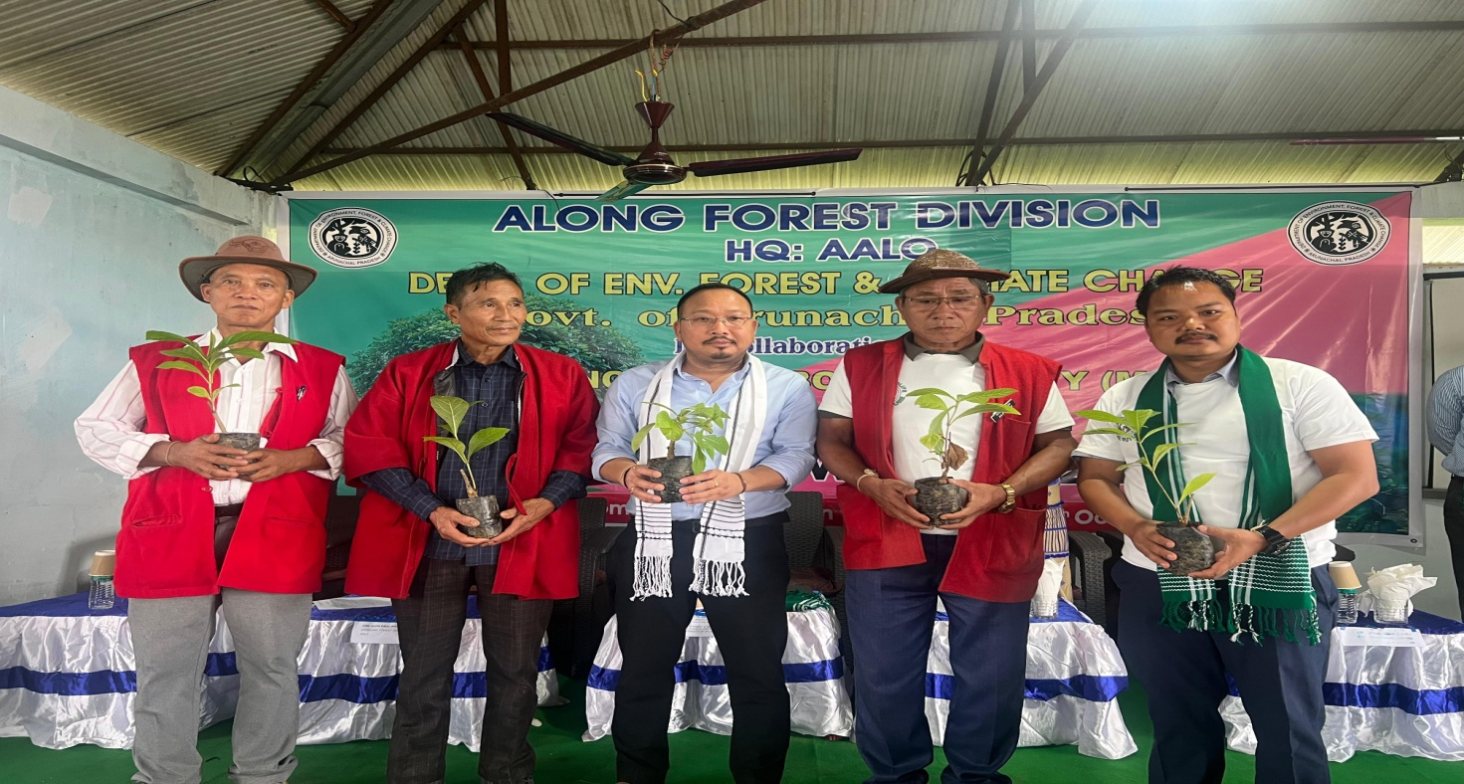
As a part of National Wildlife Week, an awareness program was organised at Tadin Village by Along Forest Division, on 6th of October2024.
The program was graced by Adv.Kento JiniHonbl,e Minister Law, Legislative & Justice, Social Justice, Empowerment & Tribal affairs, Sports & Youth Affairs as Chief guest and ADC West SiangSmtyMabiTaipodia Jini as Guest of Honour and Shri Moge Bole Dy.SP Aalo as special guest.
Welcoming the august gathering DFO Aalo Shri Gopin Padu in his address express gratitude to Migo Lengo Bone Bome Society of Tadin Village for their support and emphasisedon safeguarding wildlife and forests which plays pivotal role for human existence. Through video presentation he expresses concern over depleting wildlife and endangered species, and in detail explained the villagers about Wildlife protection Act 1972.He further advocates for conservation and protection of Wildlife through Co-Existence.
The Honb’le Minister Adv.Kento Jini appreciated the Forest Department and Migo Lengo Bone Bome Society for initiating the campaign for protection of wildlife and spear-heading awareness campaign for conservation & protection of Wildlife.In his address he stressed on Sustainable Developmentand advised Civil societies &NGO’s to support the Forest Deptt. in creating awareness among village folks. He also informed the public about various Pro-people schemes launched by the government under the dynamic leadership of Pema Khandu..
ADC Aalo SmtyMabiTaipodia Jini and Dy.SP Shri Moge Bole also spoke during the occasion.
Many colorful activities marked the event, such as distribution of forest t-shirt, free distribution of saplings etc. The program came to end with tree plantation under the campaign ‘Ek PED MAA KE NAAM’.

