Deomali Forest Division Organizes Marathon for Wildlife Week in Collaboration with NSS Unit of Wangcha Rajkumar Government College

Deomali, 7th October 2024
The Deomali Forest Division, Tirap District, in collaboration with the NSS Unit of Wangcha Rajkumar Government College, Deomali, organized a marathon as part of the National Wildlife Week celebrations. The event saw enthusiastic participation from Mr. Diwang Lowang, Deomali Range Forest Officer; Ms. Mitinam Jamoh, Borduria Range Forest Officer; Mr. Chayon Bangyang, Associate Professor, Department of Economics, Wangcha Rajkumar Government College, Deomali; and Mr. Ngamwang Lowang, Programme Officer of the NSS Unit. Also in attendance were staff members from the Forest Department, Wangcha Rajkumar Government College, Deomali, and volunteers from the NSS and NCC units of the college.

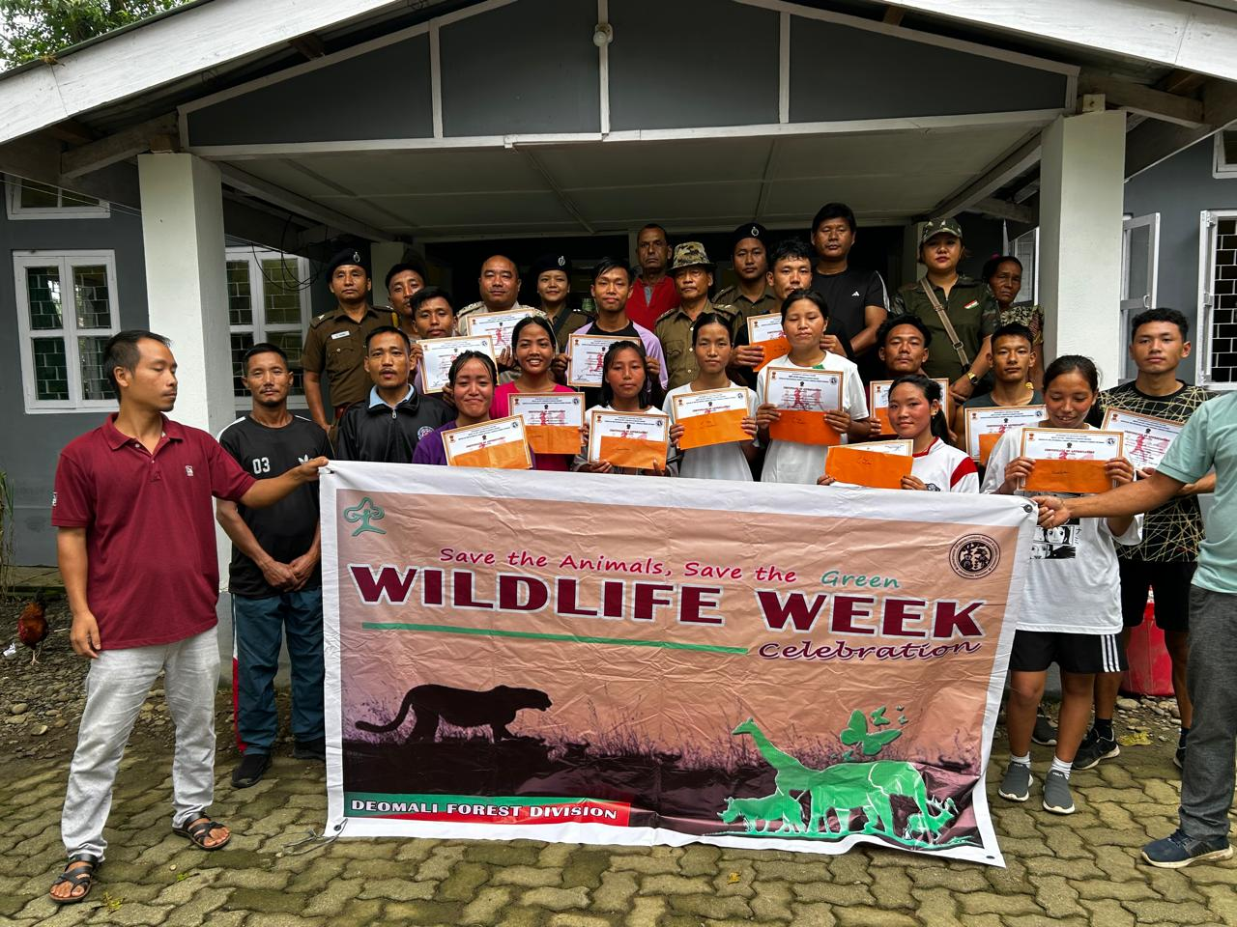

A total of 75 students participated in the marathon, which began at 5:30 AM from the Coffee Board in Deomali and concluded at the Range Forest Office, Deomali.
During the event, Mr. Diwang Lowang and Ms. Mitinam Jamoh addressed the gathering, emphasizing the importance of environmental awareness and wildlife protection in fostering a harmonious relationship between humans and nature.
Earlier, Mr. Ngamwang Lowang, NSS Programme Officer, spoke to the participants about the significance of physical fitness and mental well-being, encouraging students to adopt a healthy lifestyle.
Prizes were awarded to the top participants in both the male and female categories. In the female category, Miss Pilai Wangsa won first prize, followed by Miss Naohi Wangpan (2nd), Miss Chumto Hodong (3rd), Miss Rusen Nokbi (4th), Miss Charia Hakhun (5th), Miss Nyanam Tekwa (6th), and Miss Nelai Wangsa (7th). In the male category, Mr. Dangpho Pansa secured first place, with Mr. Phochun Chingkhowam in second, followed by Mr. Sapwang Songthing (3rd), Mr. Tahchai Wangsu (4th), Mr. Saipha Wangsa (5th), Mr. Thanjong Hansik (6th), and Mr. Ponggi Agi (7th).

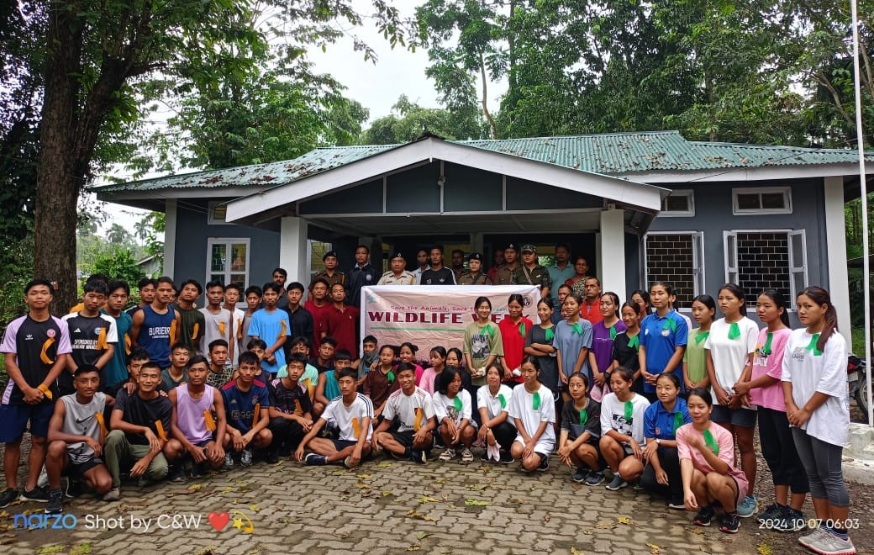

The event, officially flagged off by Ms. Mitinam Jamoh, highlighted the community's dedication to environmental preservation and youth wellness.

