GOVERNOR’S SECRETARIAT
ARUNACHAL PRADESH
ITANAGAR
Dated 18th October 2024
Press Communiqué
IPR Minister calls on the Governor

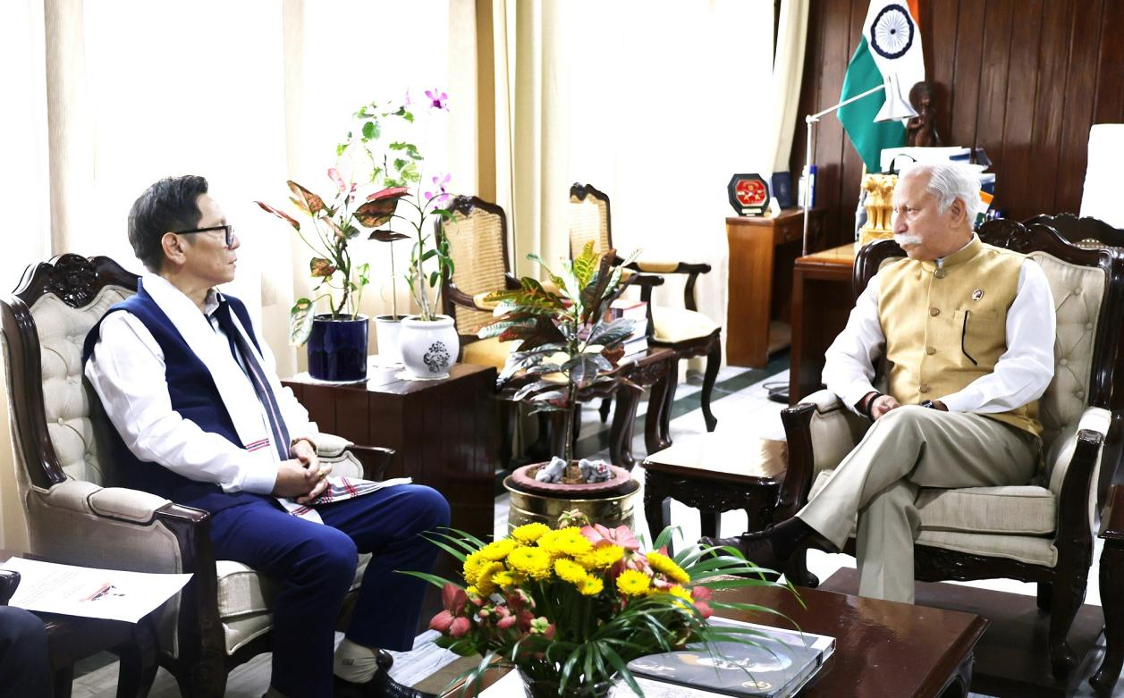
Literature activities must be promoted and organized at every educational institution as a mass movement along with State level programmes: Governor emphasizes
State can contribute to the country’s economic growth, cultural diversity and national unity, when the youth of the State are skilled and the spirit of entrepreneurship is encouraged: Governor
State Minister of Information & Public Relations, Shri Nyato Dukam called on the Governor of Arunachal Pradesh Lt. General KT Parnaik, PVSM, UYSM, YSM (Retd.) at Raj Bhavan, Itanagar on 18th October 2024. They discussed the ensuing Arunachal Literature Festival, an annual State Government event organized by the Department of Information & Public Relations in collaboration with the Arunachal Pradesh Literary Society. They also reviewed skill development, entrepreneurship and innovative avenues for Industries, Textiles and Handicrafts.
The Governor emphasized that the literature activities must be promoted and organized at every educational institution as a mass movement along with State level programmes. He said that students from schools to university must be motivated and invited to participate in the programme. He also suggested that the best of intellectuals in the literary world should be invited for the programme, where they share their experience, writings and aspirations.
The Governor advised the Minister, who also is the minister in charge of Industries, Skill Development & Entrepreneurship, Textile & Handicrafts, Trade & Commerce, Sericulture, Labour & Employment, and Printing, to explore new avenues for industry development, while prioritizing strengthening the traditional textile and handicrafts sectors. He said that the State can contribute to the country’s economic growth, cultural diversity and national unity, when the youth of the State are skilled and the spirit of entrepreneurship is encouraged.
The Governor underscored that human resource development, skill enhancement, capacity improvement and modernization and innovation integrated with technology are the key drivers of India’s aspiration to become a developed nation by 2047. In addition to it, he said that the commitment of every citizen with ‘Nation First’ spirit can create a Viksit Bharat.

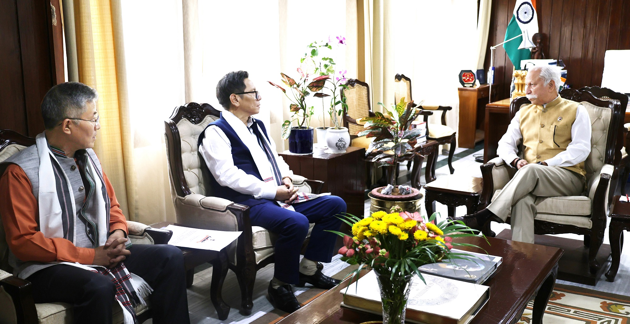
IPR Secretary Shri Nyali Ete accompanied the IPR Minister in the meeting.

