GOVERNOR’S SECRETARIAT
ARUNACHAL PRADESH
ITANAGAR
ITANAGAR, October 11, 2024

Press Communiqué

Governor participates in Durga Puja celebration
The essence of Durga Puja is not just a religious festival but also a celebration of art, culture, tradition, community, and spirituality for the people: Governor
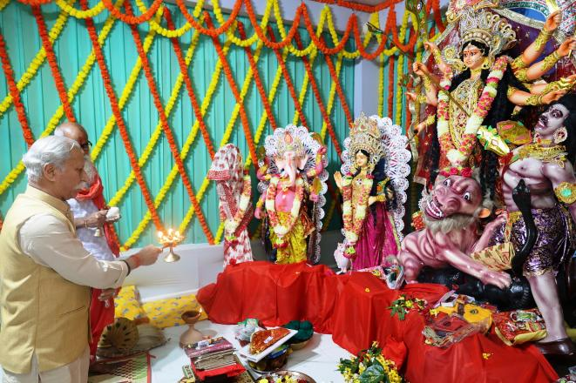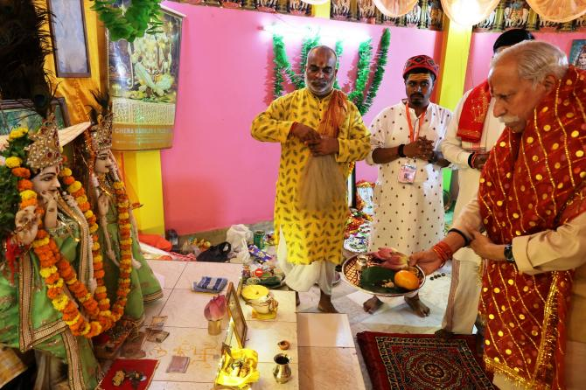
The Governor of Arunachal Pradesh, Lt. General KT Parnaik, PVSM, UYSM, YSM (Retd.), participated in the Durga Puja celebration in the Mahadev Mandir compound, B-Sector, Raj Bhavan Complex, Itanagar, on 10th October 2024. They offered prayers and performed ‘Aarti’ at the Puja pandal.
The Governor said that the essence of Durga Puja is not just a religious festival but also a celebration of art, culture, tradition, community, and spirituality for the people. He said that the Puja holds immense cultural, spiritual, and social significance for people across India.
The Governor said that the Durga Puja, which symbolizes the triumph of good over evil, also inspires all to fortify their inner strength and resilience to conquer personal battles, overcome evil tendencies, and strive for righteousness. He said the festivity also fosters a sense of unity, promotes amity amongst all sections of people and celebrates together the ultimate essence of humanity.
The Governor commended the organizing committee of the celebration and contributed a token amount towards the Puja Celebration.
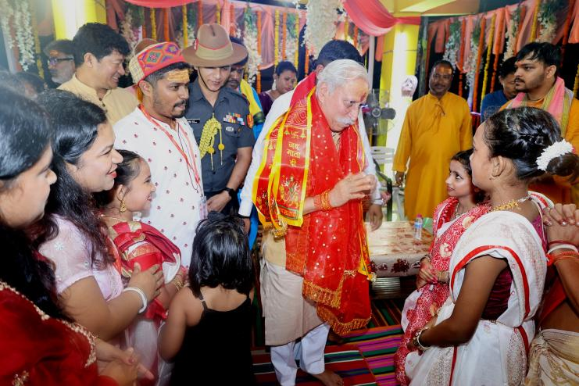
The Governor later joined the people in celebrating the auspicious occasion at Shree Radhakrishna Temple at Zero Point, Itanagar.

