GOVERNOR’S SECRETARIAT
ARUNACHAL PRADESH
ITANAGAR
Dated 23rd Oct, 2024
Press Communiqué
Education is the strongest pillar of Viksit Bharat: Governor
Governor chairs Vice Chancellors’ Conference
Governor exhorts the Vice Chancellors to focus on the quality of education, governance aspects, use of technology and social responsibilities to be adopted by the higher educational institutions
Governor urges all the stakeholders to focus on implementing the National Education Policy (NEP) 2020 in the Universities and colleges in the State
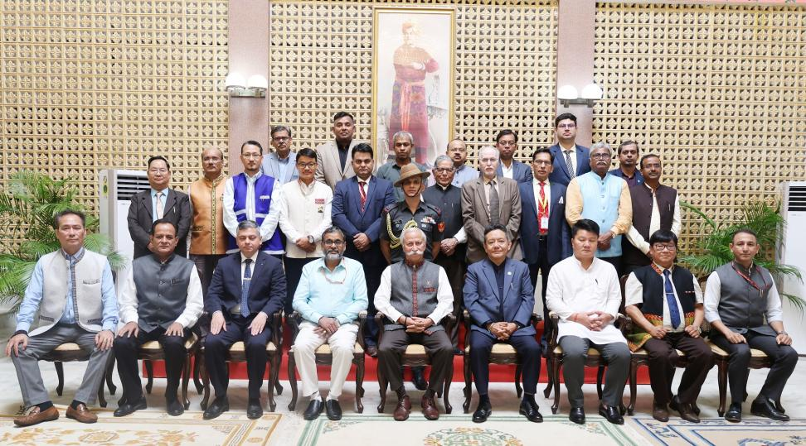
The Governor of Arunachal Pradesh Lt. General KT Parnaik, PVSM, UYSM, YSM (Red.) convened and presided over the maiden Vice Chancellors’ Conference of the State at Raj Bhavan, Itanagar on 23rd October 2024. State Education Minister Shri P.D. Sona, Adviser to Minister Education & HMLA Shri Mutchu Mithi, State Chief Secretary, Shri Manish Kumar Gupta, Education Commissioner, Shri Amjad Tak, Arunachal Pradesh Private Educational Institutions Regulatory Commission (APPEIRC) Chairman Shri Tsering Naksang, Arunachal Pradesh University Vice Chancellor Prof. Tomo Riba, Rajiv Gandhi University Prof S. K. Naik, Director, NIT, Arunachal Pradesh Prof. Mohan V Aware, Director NERIST Prof. Narendranath S.), Vice Chancellors of Private Universities along with officers from education Departments and Principals of Government colleges attended the Conference.
Speaking on the occasion, the Governor said that education is the strongest pillar of Viksit Bharat. It is an inescapable pillar of growth and development. It impacts the creation of an educated pool of professionals, including teachers, engineers, doctors & entrepreneurs. With changing times, Education also has to undergo a Transformative reform. He underscored that education is the most potent means for social transformation. Our universities and colleges have to play the role of change. Higher education is about gaining the knowledge and skills needed to become good leaders, entrepreneurs and job creators, he said.
The Governor said that the New Education Policy enunciated by the Government in 2020, has been necessitated to keep pace with developments, and challenges being faced by the nation, the overarching need to imbibe technology, to acquire knowledge to create and seek jobs. Skilling is another adjunct to education, which enables an individual to compete for jobs. He urged the stakeholders to focus on implementing the National Education Policy (NEP) 2020 in the Universities and colleges in the State.

The Governor said that NEP 2020 envisions an education system that contributes to an equitable and vibrant knowledge society, providing high-quality education to all. It emphasizes the need for a holistic, flexible, multidisciplinary approach that is aligned with the needs of the 21st century and aims to transform India into a global knowledge superpower. He urged the Vice Chancellors to create an environment and infrastructure to realize the goals of NEP 2020.
The Governor exhorted the Vice Chancellors to focus on the quality of education, governance aspects, use of technology and social responsibilities to be adopted by the higher educational institutions. He said that the need of the hour is to align our Higher Education with the Hon’ble Prime Minister’s vision of Viksit Bharat, while inspiring the participants to put in their best effort in the progress of the State and make up for the lost time.
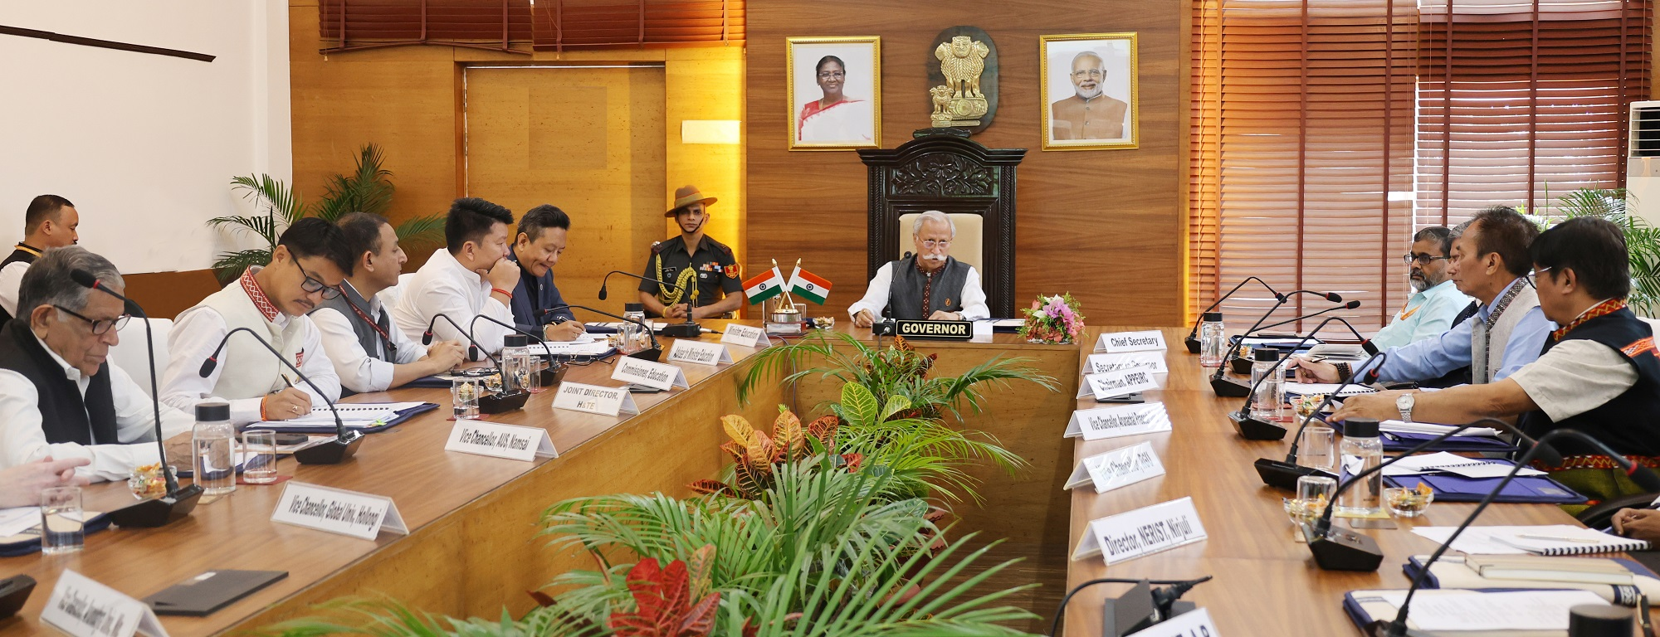
Sharing his remarks at the maiden event of the Vice Chancellors’ Conference, State Education Minister Shri P.D. Sona expressed his gratefulness to the Governor for convening the first-ever Vice Chancellors Conference of the State. He assured the Governor to take corrective measures and explore ways for the implementation of NEP 2020 in letter and spirit.
Prof. Utpal Bhattacharjee, Director IQAC & Chairman, NEP Task Forces, RGU presented a PPT on National Education Policy 2020, while Dr. Ravi Ranjan Kumar, Coordinator, NEP-2020 & Convener, NEP Task Force, RGU presented on ‘Governance’. Dr. Upamanyu Das, Deputy Director, Institute of Under Graduate Studies & Member, NEP Task Force, RGU presented a PPT on ‘Curriculum Framework for UG and PG Programme, while Prof. C. Shiv Sankar, Department of Education, RGU gave a presentation on ‘Quality of Education’. Prof Tomo Riba, Vice Chancellor, Arunachal Pradesh University, Pasighat gave a PowerPoint presentation on ‘Employability & Social Responsibility at the daylong Vice-Chancellors’ Conference. Prof. S. Chakraborty, Dean Academic, NIT, Arunachal Pradesh presented a PPT on ‘Usage of Technology’.

