GOVERNOR’S SECRETARIAT
ARUNACHAL PRADESH
ITANAGAR
24th October 2024

Press Communiqué
French Ambassador calls on the Governor
Governor suggests cultural exchange programmes with the State
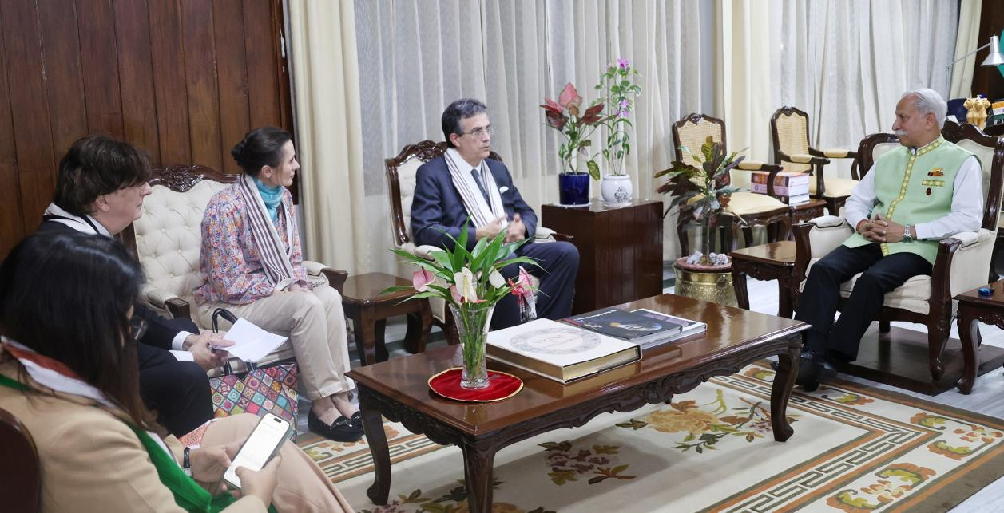
The French Ambassador to India Mr. Thierry Mathou called on the Governor of Arunachal Pradesh Lt. General KT Parnaik, PVSM, UYSM, YSM (Retd.) at Raj Bhavan, Itanagar on 24th October 2024. They discussed avenues for sustainable adventure and eco tourism, agricultural and poultry cold chain management as well as building capacities in biodiversity.
The Governor highlighted the perspective of Arunachal Pradesh in the hydropower, agriculture and allied sectors, cultural diversity and tourism. He also underscored the avenues feasibility for technology-based industries and infrastructures.
The Governor also suggested cultural exchange programmes with the State.

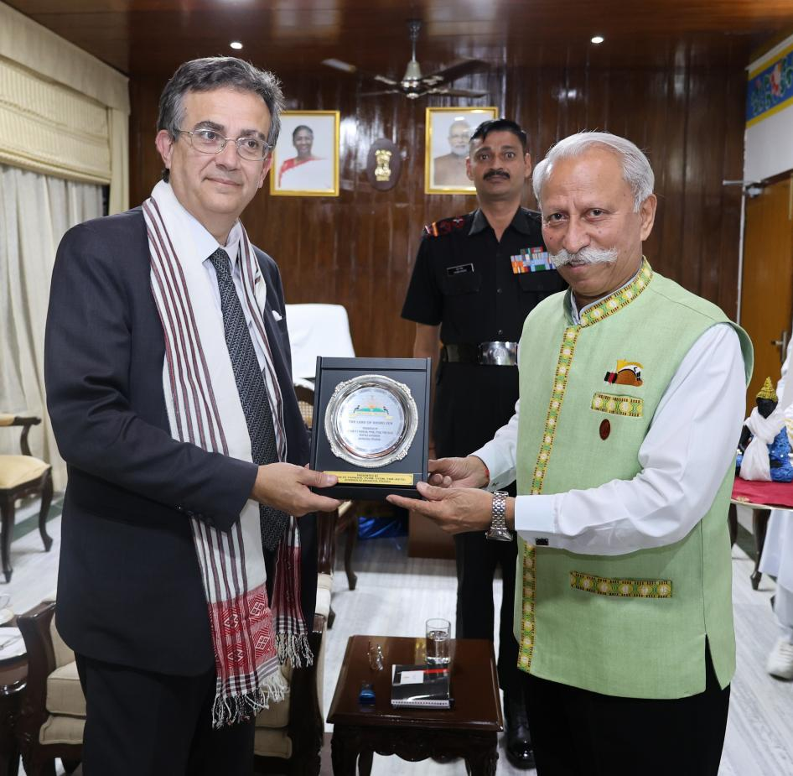
Mr. Mathou, who is on a 5-day tour of Arunachal Pradesh, was accompanied by his wife Mrs. Cecile Mathou, Consul General of France in Kolkata Mr. Didier Talpin, Cooperation Officer Mr. Samuel Bouchard and Press & Diplomatic Liaison Officer Ms. Anjita Roychaudhury in the meeting. They will be visiting Bhalukpong, Dirang and Tawang during the tour.

