Sept 27, 2024
Press Release

Darang pitches for “Cleaner & Greener Pasighat”
PMC & DA organize ‘ Walkathon ’ as part of Swachhata Hi Seva

Local MLA Tapi Darang, today has pitched for a “ cleaner & greener “ Pasighat through people’s participation in making their city a truly livable city and to take ownership for their own city’s cleanliness and hygiene . The Pasighat MLA said this while joining a “ Walk for Green & Clean Pasighat” organized by the Pasighat Municipal Council (PMC) in Collaboration with East Siang District Administration as part of the ongoing Swachhata Hi Seva(SHS) Campaign . An estimated 800 plus participated in the Swachhata Walkathon .

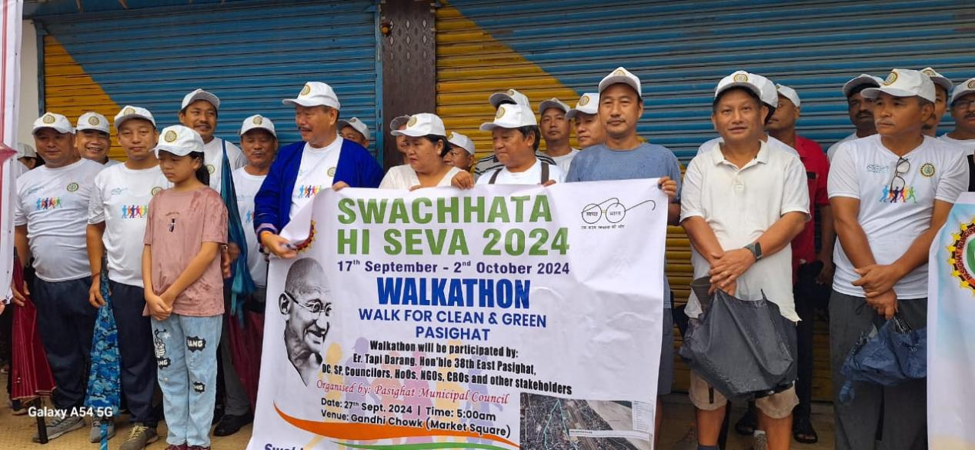

DC Incharge Tatling Pertin, SP Dr. Sachin Kumar Singhal ,PMC Chief , Okiam Moyong Borang, Vice-Chancellor, A P State University, Tomo Riba, DDSE Odhuk Tabing, Lead Bank Manager S.Basumatary, Nodal Officer for district SHS cum EE PMC ,Tadar Tarang also participated the Walkathon for awareness on cleanliness. Pasighat Market Association (PMA) members , Bogong Banggo Kebang,Bogong Bannggo Yameng Kebang, BRO, JNC NCC & NSS students, CBOs, NGOs,Councillors of PMC, PRI leaders, HoDs/ HoOs/ and students and general public also participated,
Earlier,District Nodal Officer for Swacchata Hi Seva 2024 & EE PMC ,Tadar Tarang earlier highlighted on the ward to ward cleanliness drives and awareness on source segregation for garbage free Pasighat and the objective of the Walkathon.
The walkathon began from Gandhi Chowk,Main Market via DC Bungalow Junction- Officers Colony -Siang Guest House and culminated at Gandhi Chowk. JNC NCC & NSS Team members after covering JNC & Raneghat also culminated at Gandhi Chowk.

