Press Release:
DC INAUGURATES LIBRARY MEETING ROOM AT KHONSA.

Khonsa, October 7, 2024: The highly anticipated Library Meeting Room, envisioned by Deputy Commissioner Ira Singhal, IAS was officially inaugurated today at the District Secretariat Building in Khonsa. The inaugural ceremony was graced by the presence of all administrative officers and DC’s office staff, Khonsa marking an important step towards enhancing the work environment for government employees in the district.

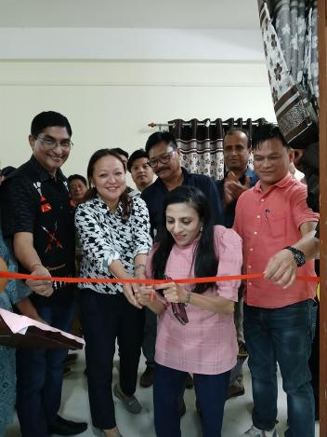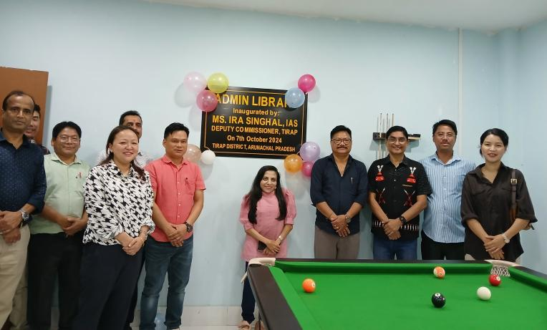

While inaugurating the facility, DC Ira Singhal highlighted the multiple purposes the Library Meeting Room will serve. "The Library Meeting Room aims to provide a versatile space where employees can relax and recharge, bond with colleagues, enjoy their meals, and also maintain their productivity. In addition to this, the room can be used as a venue for official meetings, discussions, and collaborative efforts," she said.

