7th Oct, 2024
Press Release:
COMMISSIONER INDUSTRY REVIEWS PM VISHWAKARMA YOJANA STATUS IN AP
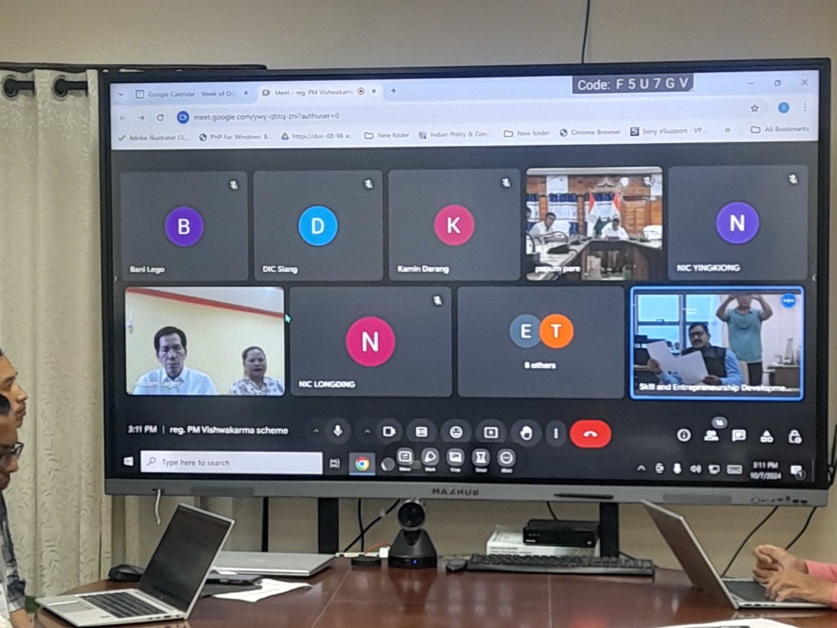
Itanagar, 7th Oct ‘2024: A virtual review meeting of PM Vishwakarma Yojana (PMVJ) was held under the chairmanship of Sougat Biswas, Commissioner
Industries and Skill Development with all the Deputy Commissioners of the Districts here yesterday.
Commissioner Biswas informed the DC’s and District Panchayat Development Officers (DPDO) that PMVJ has 18 trades namely Carpenter, Boat Maker, Armourer, Blacksmith, Hammer & Toolkit maker, Locksmith, Goldsmith, Potter, Sculptor, Stone Carver, Stone Breaker, Cobbler/Shoe smith/ Footwear artisan, Mason, Traditional Basket/Mat/Broom maker/Coir Weaver/Doll & Toy maker, Barber, Garland maker, Washerman, Tailor and Fishing Net maker.
While informing the participating DCs and DPDOs that most of the Districts had achieved satisfactory level of Gram Panchayat Chairpersons on-boarding on PM Vishwakarma portal, Biswas also informed that many Districts were still lagging behind in the on-boarding of GPCs who has to verify the 1st stage application process of the artisans.
All the participating DCs and DPDOs enthusiastically interacted with the Commissioner and highlighted the achievements and challenges faced at the
Districts and shared their action plans to achieve 100% on-boarding during next week.
The PM Vishwakarma Yojana is a flagship program of Government of India which has potential to change the socio-economic status of traditional artisans. The scheme will facilitate product improvement of the artisans and integrate artisans into market-platforms such as GeM, ONDC, etc. The implementation of PMVJ is directly monitored by the Prime Minister’s Office through PRAGATI platform.

