PRESS RELEASE
Career Counseling program conducted at Donyi Polo Government College , Kamki

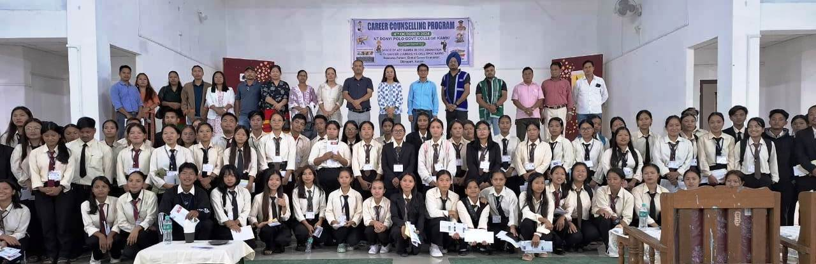
The 2 (two) Days Career Counseling program for students of various schools under Kamba Sub Division was started today at DPGC Kamki in presence of Deputy Commissioner of West Siang Ms Mamu Hage IAS. The counselor from the Global Career counseling students welfare centre Dibrugarh, Assam organised the counseling program . Around 300 students and 30 faculties member of various institution attended the counseling.
ADC Kamba Sri T Riba who organised the event inform that there are another two session on 5th October at Kamba GHSS and GSS Darak for benefit of the students.
Eight teachers were appointed as consultants and they will be trained in these 2 days in sidelines of the students counseling sessions. These teachers shall mentoring, guiding and counseling the students on career related issues.
DC West Siang Mamu Hage IAS advised the students to do SWOT analysis of own traits and decide on their career accordingly. Apart from many other career avenues the counselor informed about the exams of UPSC,SSC,SSB,IBPS that students could take after their graduations. The students were made to do a self assessment of own skills through a small questionnaire.

