PRESS RELEASE

CM Pema Khandu Inaugurates Kameng Culture and Heritage Museum in Nyukmadung
October 23, 2024

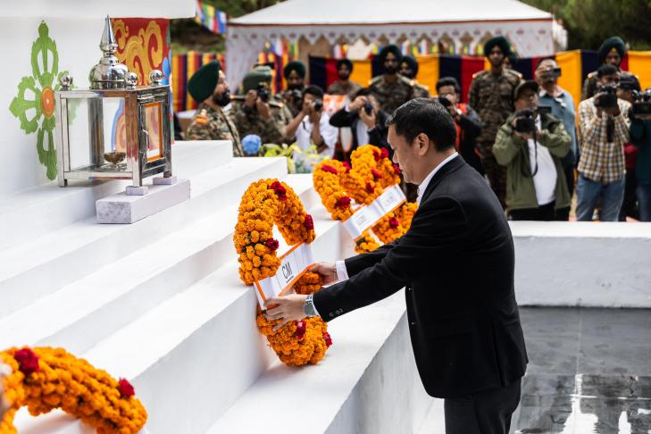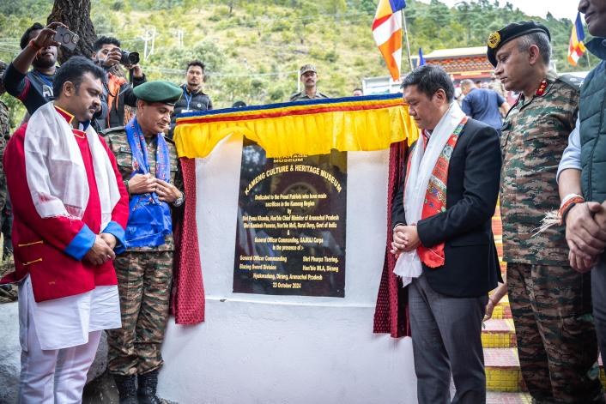
Chief Minister Pema Khandu, in presence of Union Minister of State for Rural Development Kamlesh Paswan, today dedicated the Kameng Culture and Heritage Museum here at Nyukmadung to the people.
Khandu in his brief speech said that this unique institution recognizes and showcases the martial, cultural, and heritage prowess of Arunachal Pradesh and celebrates the historical linkages of this ancient region with Bharatvarsh.
“This location of the Museum, at Nyukmadung is of special reverence to all of us as it proudly marks the sacrifice, bravery and honour of the Indian Army during the 1962 war alongwith the camaraderie and compatriotism of local people. This museum is not just a repository of artefacts, heirlooms and memories but a living bridge between the past and future,” he said.
Khandu expressed optimism that the museum is poised to place Nyukmadung and Dirang on the tourist map boosting religious and adventure tourism. It will not only contribute to local economy but also foster a deeper understanding of the region’s cultural canvas on national and global stage, remarked.
He appreciated the efforts put in by the Indian Institute of Heritage (IIH) under its Vice Chancellor Dr. B R Mani and Prof. Manvi Seth. Seth was also present during the inaugural ceremony.
The Chief Minister acknowledged the remarkable work done by IIH under the leadership of Dr Mani and Prof Seth in preparing an informative catalogue on the Museum which highlights local heroes of 1962 War who fought shoulder to shoulder with Indian Army in 1Indo-China War.
He said that the Indian Army’s initiative through Operation SADBHAVANA contributes directly to Border Area Development and Vibrant Village Programme of Government of India and urged the Indian Army as well as the CAPF units of ITBP and SSB, who huard the frontiers of Arunachal Pradesh to undertake collaborative development programmes for development of border villages and welfare of the people living along the border.
“Such collaborative efforts will also boost tourism and generate employment opportunities for the people,” Khandu said.
He further urged the Civil Administration and Indian Army to synergize efforts for
transformational changes for overall development of people of the region.
Khandu also expressed gratitude to the entire team of Sela Brigade, 16 Madras and 18 Sikh Light Infantry who worked with zeal to deliver the historic project.
A film by Capt Praveen Chaturvedi, CEO, Moonlight Pictures and his team, was screened during the event that highlighted the deep- rooted connect of Arunachal Pradesh and Bharat.
The museum also has facilities like a children’s park, a cafeteria, a souvenir shop and a movie hall.
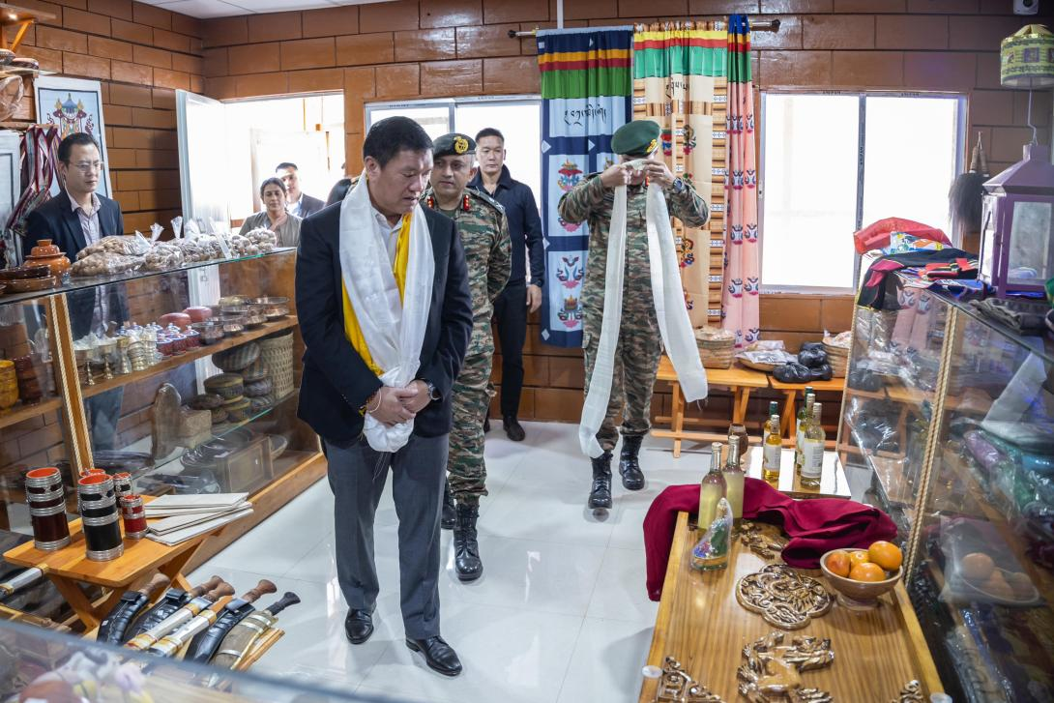
Present in the inaugural programme, amongst others, were state’s Rural Development minister Ojing Tasing, local legislator Phurpa Tsering, Kalaktang Legislator Tsetan Chombay, General Officer Commanding, 4 Corps, Lieutenant General Gambhir Singh, Gajraj Corps General Officer Commanding, Gajraj Corps and General Officer Commanding, Blazing Sword Division, Maj Gen Neeraj Shukla.

