GOVERNOR’S SECRETARIAT
ARUNACHAL PRADESH
ITANAGAR

Press Communiqué
Australian High Commissioner calls on the Governor
Governor, Australian High Commissioner to India discusses entrepreneurship, skill development, technology, mineral exploration, hydropower, tourism, and bilateral venture avenues

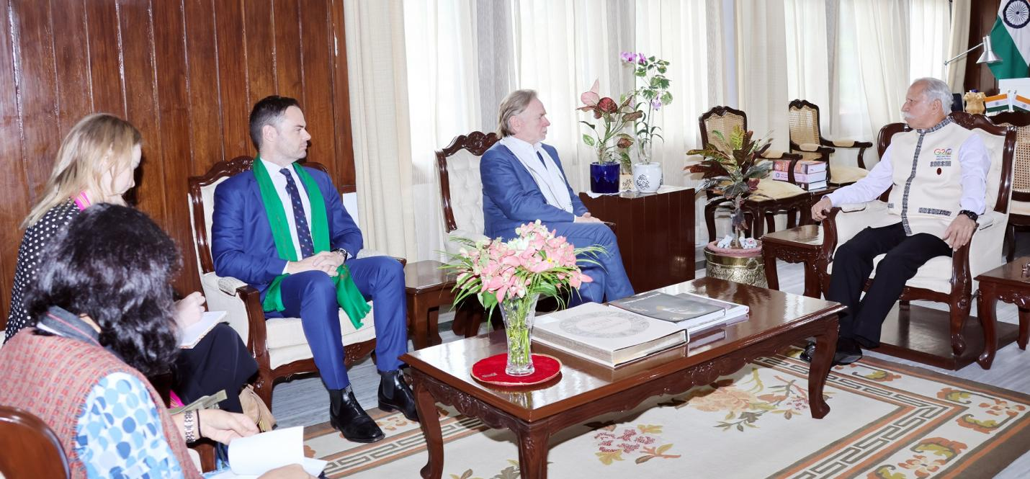
Australian High Commissioner to India, Mr. Philip Green called on the Governor of Arunachal Pradesh Lt. General KT Parnaik, PVSM, UYSM, YSM (Retd.) at Raj Bhavan, Itanagar on 7th October 2024. They discussed entrepreneurship, skill development, technology, mineral exploration, hydropower, tourism, and bilateral venture avenues.
The Governor emphasized the capacity of the youth of the State in entrepreneurship, skill development and technology sectors through exchange programmes. He said that the youth of the State have potential but need exposure and specialized assistance.
The Governor highlighted the tourism perspective of Arunachal Pradesh, in eco, adventure and cultural tourism. He said that the State provides an array of avenues for tourism activities.

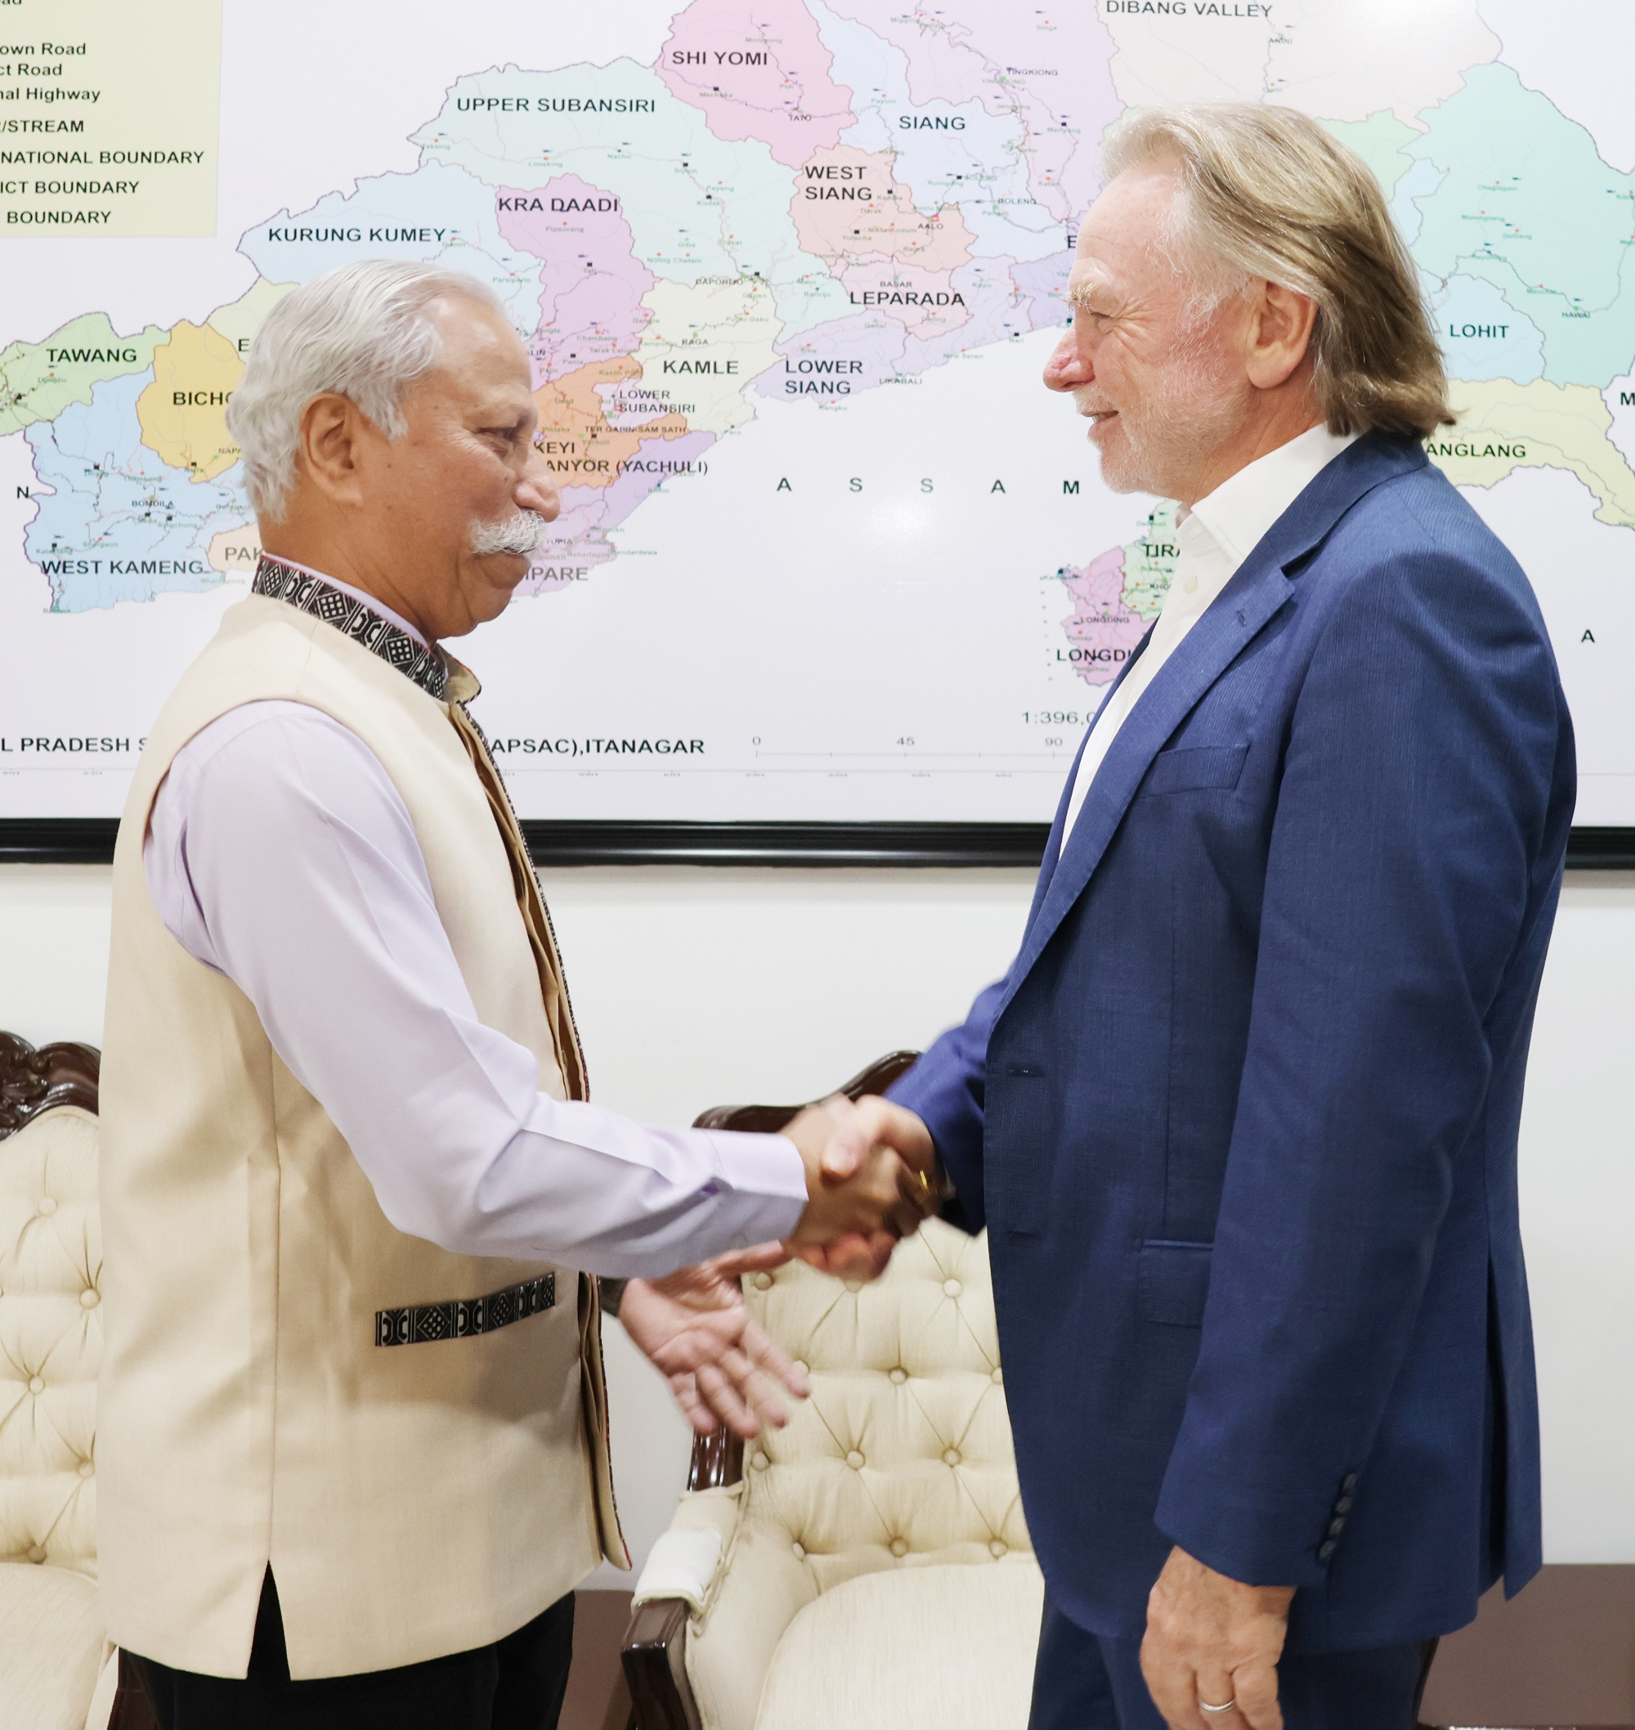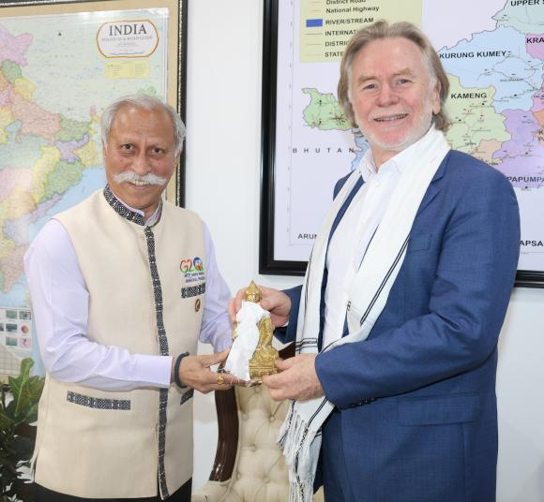
The Governor also discussed the mineral potential of the State and requested if prospecting of minerals could also be considered as a matter of cooperation.
The Governor underscored the rich cultural and traditional heritages of indigenous tribal communities of Arunachal Pradesh. He pointed out that the State has a huge scope for research, anthropology studies and flora and fauna.
The High Commissioner, who is on a five-day visit to Arunachal Pradesh, appreciated the State and its people.
Australian Consul General, Kolkata, Mr. Hugh Boylan, Vice Consul, Bengaluru, Ms. Harriet White, and Senior Research Officer (Political) Ms. Vandana Seth accompanied the High Commissioner.

