Oct 5, 2024
Press Release

“Bring in new techniques to make your teaching interesting”: ADC Tezu Kunal Yadav IAS., exhorts B. Ed trainees.
Teachers’ Orientation programme for Reading Aloud skills held at Bamboosa Library

“You have seen that teaching reading skills can be by interesting and enjoyable ways too.. Use these techniques in your classrooms and with the children around you, to make their learning friendly.”, said Kunal Yadav, IAS., Addl Deputy Commissioner, Tezu, as he delivered the valedictory address of the 3-day orientation training for B. Ed teacher-trainees who have volunteered for the RASA-3 (Read Aloud Sessions for All ) programme. “As I come to the Bamboosa Library, I feel a bit of regret also that in my school days, I was never exposed to such student-friendly activities”. Pointing out that today students are highly perceptive, he appealed to the teachers to be imaginative and conduct sessions with emotions, and entering into the character of the stories they teach.

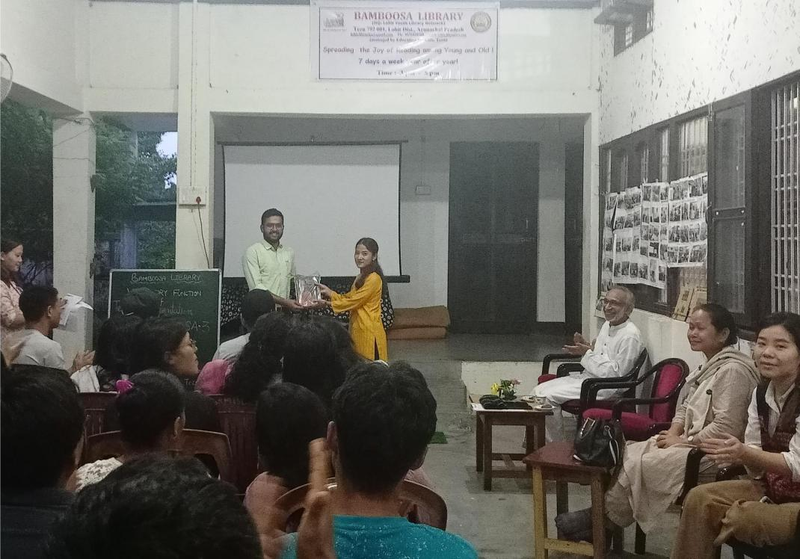

RASA is a unique voluntary initative by Bamboosa Library and the Denning College for Teacher Education (DCTE ), Tezu, conducted jointly with DDSE Tezu from 2022, to help Govt middle school students of Tezu, to improve their loud reading skills, using volunteers from B. Ed trainees.

Earlier, outlining the objectives of RASA-3, senior volunteer Solina Kambrai lauded the DCTE for their committed support and thanked Asstt Prof. Mimu Linggi for her spirited involvement, for the 3rd year successive year of RASA. Thereafter the B. Ed trainees presented poem recitation demonstrations, followed by junior volunteers of Bamboosa Library Anushka and Arpita.

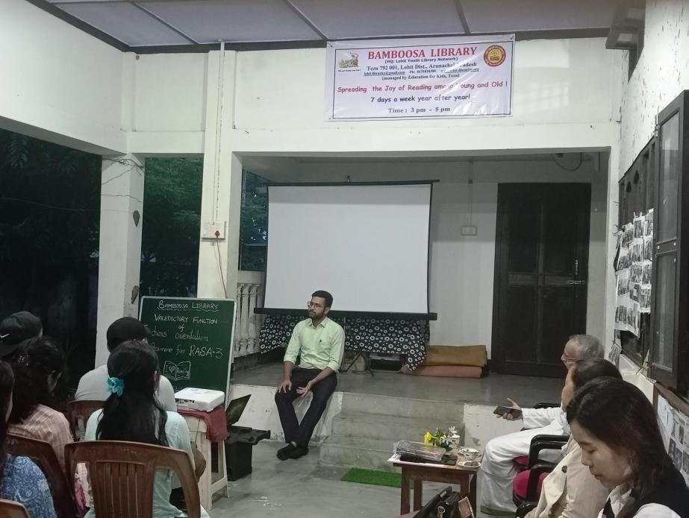

Senior volunteer Sakelu Chikro, welcomed the guests and said “We shall never forget the very friendly and supportive nature of Sri Kunal sir, towards any student in distress”. Proposing a vote of thanks, Keselo Tayang, Secretary, Forum of Library Activists, Medo, wished Sri Yadav, who is going on transfer from Tezu, many happy and successful years of service in higher responsibilities.

