GOVERNMENT OF ARUNACHAL PRADESH DEPARTMENT OF SPORTS
CHIMPU, ITANAGAR
No. DS/HDMT/PR/01/2024 Dated Namsai 7th Oct, 2024
SUB : PRESS RELEASE OF 7TH HANGPAN DADA MEMORIAL TROPHY 2024- DAY 4

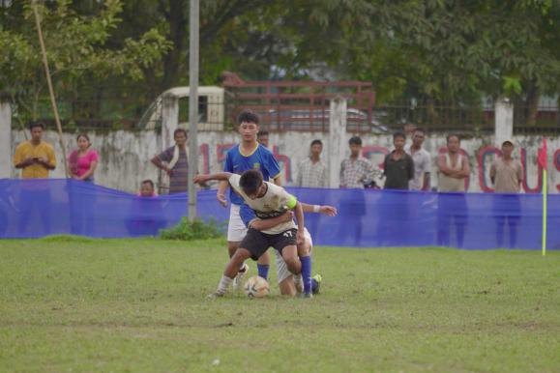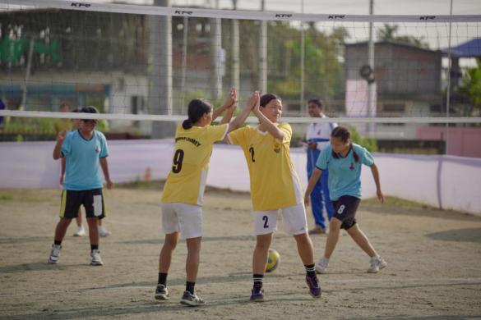
The 7th Hangpan Dada Memorial Trophy 2024 continued to deliver thrilling performances on Day 4, showcasing the talents of young athletes in both volleyball and football competitions. The day was filled with intense matches and impressive displays of skill across all events.
In the girls' volleyball matches, Kamle triumphed over Tirap with scores of 25/14 and 25/8. Anjaw defeated Pakke Kessang with scores of 16/25 and 15/25, while Shi Yomi emerged victorious against Tawang, winning 14/25 and 16/25. Namsai showcased a strong performance against Upper Subansiri, winning 25/22 and 25/11. Kurung Kumey defeated West Kameng with scores of 8/25 and 12/25. Longding also secured a win by walkover against East Kameng.
In the boys' volleyball results, Upper Subansiri defeated Anjaw with scores of 25/13 and 25/14. Pakke Kessang won by walkover against Siang, while Shi Yomi claimed victory over Kra Daadi, with scores of 20/25 and 8/25. Namsai triumphed over Lepa Rada, winning 25/18 and 25/20. The match between Dibang Valley and Upper Siang was not reported, and Capital Complex won by walkover against West Kameng.
The football matches also brought excitement, starting with the girls' results. Papum Pare and Lepa Rada ended their match in a 0-0 draw. East Kameng defeated Anjaw with a score of 1-0, while Tawang triumphed over Upper Subansiri, winning 2-0. Kra Daadi won against West Kameng by 1-0, and East Siang secured a victory over Siang with a score of 2-0. Longding and Lower Siang ended in a 1-1 draw. Changlang won by walkover against Dibang Valley, and Capital Complex achieved a walkover victory against Upper Siang.
In the boys' football results, Namsai won by walkover against Upper Siang. Lohit defeated Pakke Kessang with a score of 2-1, while Lower Siang secured a walkover victory against Lower Subansiri. West Kameng triumphed over Tawang with a resounding score of 12-0. Longding and Kra Daadi played to a 0-0 draw, and Siang defeated Kamle with a score of 2-1. Finally, Upper Subansiri won against Lower Dibang Valley with a score of 4-0, and West Siang triumphed over Papum Pare, winning 5-0.

