GOVERNOR’S SECRETARIAT
ARUNACHAL PRADESH
ITANAGAR
27th September 2024

Press Communiqué
Take pride in the fact that you belong to a country with a vibrant and timeless culture: Governor to students
Governor interacts with Tawang and West Kameng District students
Governor commends the Gajraj Corps (4 Corps) for organizing the tour for students in their area of responsibility

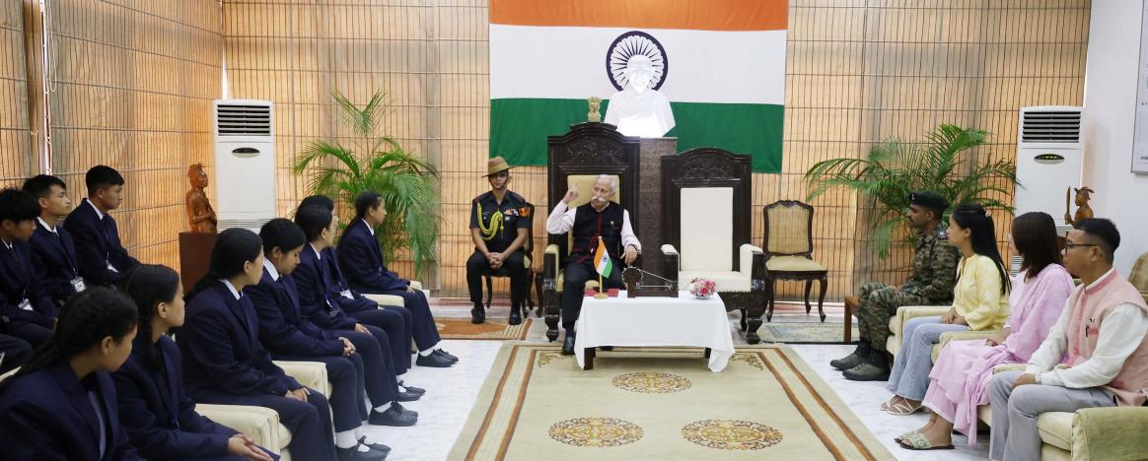
The Governor of Arunachal Pradesh Lt. General KT Parnaik, PVSM, UYSM, YSM (Retd.) interacted with the students from Tawang and West Districts, who participated in the National Integration Tour to Delhi and Mussoorie at Raj Bhavan, Itanagar on 27th September 2024.
The Governor encouraged the students to take to heart the experience of the tour and let it inspire them to become more informed, more respectful, and more responsible individuals. He said that India’s strength lies in its people, and the students of the day are the future. With knowledge and a deep understanding of our country, they can contribute to Viksit Bharat@2047 making India even greater, he said.
The Governor said that India is truly unique in its ability to harmonize a variety of traditions, languages, landscapes, and lifestyles on the principle of unity in diversity. He advised the students and teachers to take pride in the fact that they belong to a country with a vibrant and timeless culture. Share this pride with others and let it inspire them to contribute positively to our community and country, he said.
The Governor commended Gajraj Corps (4 Corps) for organizing the tour for students in their area of responsibility.

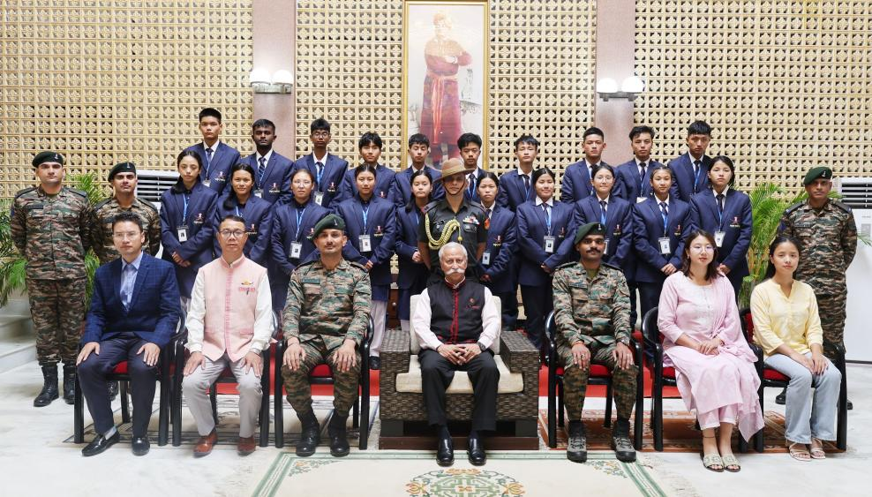
Major Ashish Singh, the officer in-charge of the tour briefed the Governor that the twenty selected boys and girls from Government Higher Secondary School, Jang, Tawang District and Government Higher Secondary School, Dirang, West Kameng District along with the teachers participated in the National Integration Tour, named as ‘Vigyan Siksha Bhraman’, which started on 18th September 2024.
The students and the teachers visited prestigious institutions and landmarks in the national capital, Rashtrapati Bhawan, the new Sansad Bhavan and IIT Delhi. They also visited the Indian Military Academy and Rashtriya Indian Military College in Dehradun, Lal Bahadur Shastri National Academy of Administration (LBSNAA) and Mindrolling Monastery in Mussoorie.

